CE Calendar (Common Era)
# Source: AI Source: Provided by: [Data Path: Persons Table -> ID Column: 1, Name_En Column: Motasem Essam] -> From: [ChatGPT] on [7/17/2026]
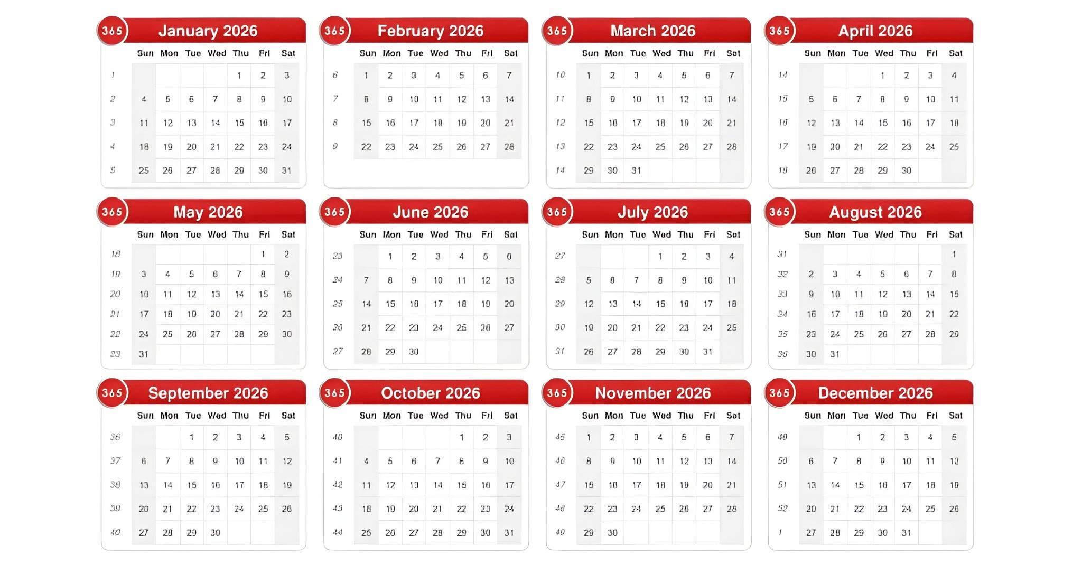
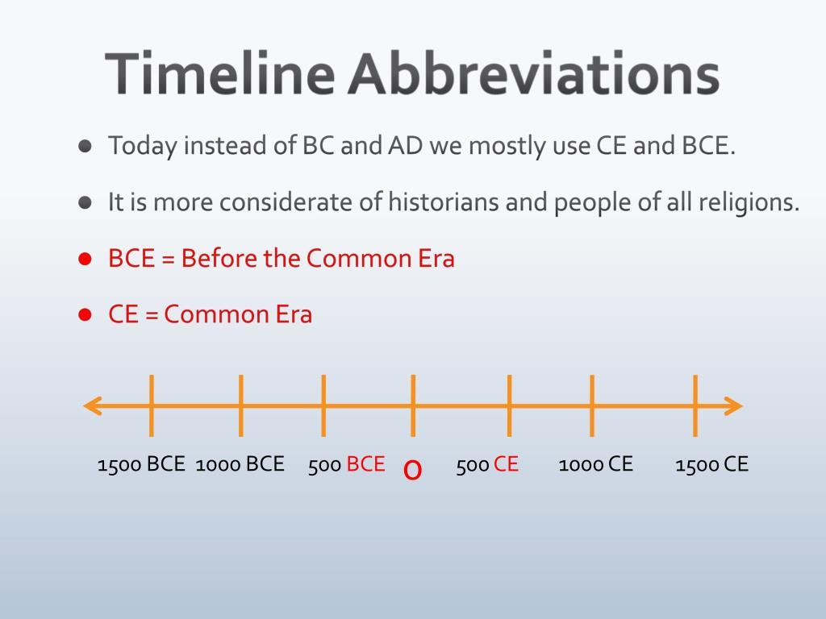

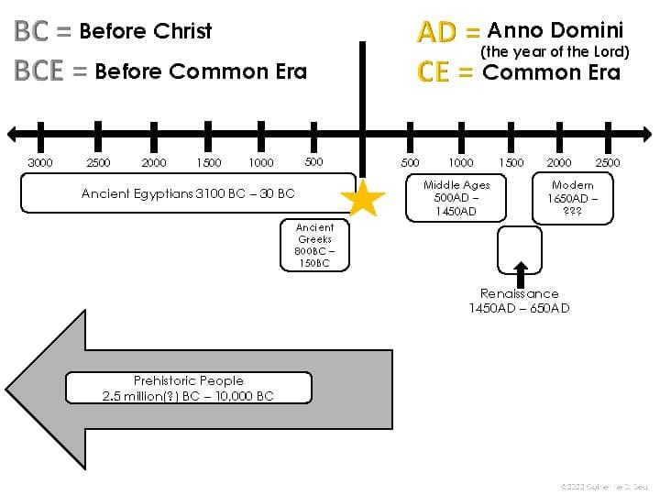

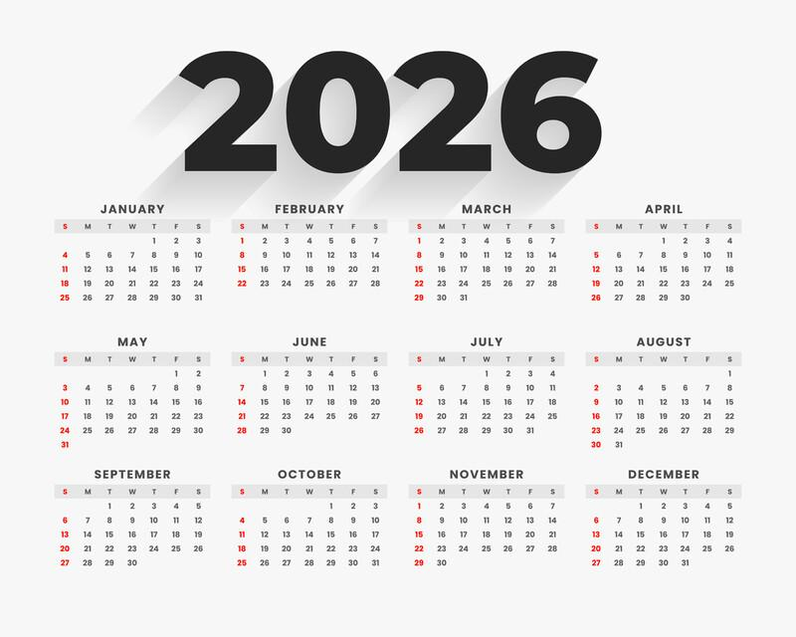
The CE Calendar (Common Era) is the modern, secular year-numbering system used with the Gregorian Calendar. It uses the same year numbers as the traditional AD (Anno Domini) system but avoids religious terminology.
Today, CE is widely used in:
- Education
- Science
- Archaeology
- History
- International publications
- Academic research

Definition
# Source: AI Source: Provided by: [Data Path: Persons Table -> ID Column: 1, Name_En Column: Motasem Essam] -> From: [ChatGPT] on [7/17/2026]
The Common Era (CE) is a year-numbering system that uses the same numbering as the AD system while employing non-religious terminology.
For example:
- 2026 CE is exactly the same year as AD 2026.

Meaning of CE
# Source: AI Source: Provided by: [Data Path: Persons Table -> ID Column: 1, Name_En Column: Motasem Essam] -> From: [ChatGPT] on [7/17/2026]
CE stands for:
Common Era
It is paired with:
BCE — Before Common Era
Together they replace the traditional terms:

Traditional | Modern Equivalent
BC | BCE
AD | CE
The year numbers remain identical.

Historical Background
# Source: AI Source: Provided by: [Data Path: Persons Table -> ID Column: 1, Name_En Column: Motasem Essam] -> From: [ChatGPT] on [7/17/2026]
The concept of using neutral terminology became increasingly common during the 18th and 19th centuries, especially among historians and scholars.
The widespread adoption of CE/BCE aims to provide terminology that can be used universally regardless of religious background.

Relationship to AD
# Source: AI Source: Provided by: [Data Path: Persons Table -> ID Column: 1, Name_En Column: Motasem Essam] -> From: [ChatGPT] on [7/17/2026]
The CE system is not a different calendar.
It uses:
- The same years
- The same months
- The same leap-year rules
- The same Gregorian Calendar
Only the names change.
Examples:

AD | CE
AD 1 | 1 CE
AD 1066 | 1066 CE
AD 2026 | 2026 CE

Relationship to BCE
# Source: AI Source: Provided by: [Data Path: Persons Table -> ID Column: 1, Name_En Column: Motasem Essam] -> From: [ChatGPT] on [7/17/2026]
Years before the Common Era are labeled:
BCE (Before Common Era)
Example timeline:
2 BCE → 1 BCE → 1 CE → 2 CE → 3 CE → ... → 2026 CE

No Year Zero
# Source: AI Source: Provided by: [Data Path: Persons Table -> ID Column: 1, Name_En Column: Motasem Essam] -> From: [ChatGPT] on [7/17/2026]
Like the AD system, the CE system has:
No Year 0
The sequence is:
- 2 BCE
- 1 BCE
- 1 CE
- 2 CE

Calendar Used
# Source: AI Source: Provided by: [Data Path: Persons Table -> ID Column: 1, Name_En Column: Motasem Essam] -> From: [ChatGPT] on [7/17/2026]
The CE year-numbering system is primarily used with the:
- Gregorian Calendar
Historically, it can also be applied when discussing dates in the Julian Calendar, provided the calendar is clearly identified.

Applications
# Source: AI Source: Provided by: [Data Path: Persons Table -> ID Column: 1, Name_En Column: Motasem Essam] -> From: [ChatGPT] on [7/17/2026]
The CE system is widely used in:
- Schools and universities
- Scientific journals
- Archaeology
- Museums
- Historical publications
- International organizations
- Government documents
- Academic writing

Advantages
# Source: AI Source: Provided by: [Data Path: Persons Table -> ID Column: 1, Name_En Column: Motasem Essam] -> From: [ChatGPT] on [7/17/2026]
The CE system:
- Uses internationally neutral terminology.
- Retains compatibility with the AD numbering system.
- Avoids religious wording.
- Is widely accepted in multicultural and international contexts.

Limitations
# Source: AI Source: Provided by: [Data Path: Persons Table -> ID Column: 1, Name_En Column: Motasem Essam] -> From: [ChatGPT] on [7/17/2026]
- Some historical and religious documents continue to use AD/BC.
- Readers unfamiliar with CE/BCE may initially confuse the abbreviations.

Common Mistakes
# Source: AI Source: Provided by: [Data Path: Persons Table -> ID Column: 1, Name_En Column: Motasem Essam] -> From: [ChatGPT] on [7/17/2026]
- Thinking CE represents a different calendar from AD.
It does not.
- Assuming the year numbers change.
They remain exactly the same.
- Believing there is a Year 0.
There is not.

Interesting Facts
# Source: AI Source: Provided by: [Data Path: Persons Table -> ID Column: 1, Name_En Column: Motasem Essam] -> From: [ChatGPT] on [7/17/2026]
- CE and AD refer to the same years.
- The Gregorian Calendar is the world's most widely used civil calendar, regardless of whether dates are written as AD or CE.
- Many universities, museums, encyclopedias, and scientific organizations prefer CE/BCE because of its neutral terminology.

Comparison with AD
# Source: AI Source: Provided by: [Data Path: Persons Table -> ID Column: 1, Name_En Column: Motasem Essam] -> From: [ChatGPT] on [7/17/2026]
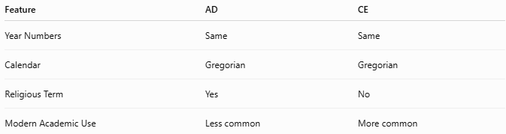
Feature | AD | CE
Year Numbers | Same | Same
Calendar | Gregorian | Gregorian
Religious Term | Yes | No
Modern Academic Use | Less common | More common

Key Points
# Source: AI Source: Provided by: [Data Path: Persons Table -> ID Column: 1, Name_En Column: Motasem Essam] -> From: [ChatGPT] on [7/17/2026]
- CE stands for Common Era.
- It uses the same year numbering as AD.
- It is paired with BCE (Before Common Era).
- There is no Year 0.
- CE is widely used in academic, scientific, and international contexts.

Conclusion
# Source: AI Source: Provided by: [Data Path: Persons Table -> ID Column: 1, Name_En Column: Motasem Essam] -> From: [ChatGPT] on [7/17/2026]
The CE Calendar (Common Era) is the modern, secular year-numbering system used with the Gregorian Calendar. It is numerically identical to the traditional AD (Anno Domini) system, differing only in terminology. By replacing religious labels with neutral ones, CE/BCE provides a universally accepted method of expressing dates while preserving the same chronological sequence used throughout the modern world.

